From Dive Magazine: http://divemagazine.co.uk/travel/8037-advances-in-marine-archaeology
Mission Possible: Marine Archaeology
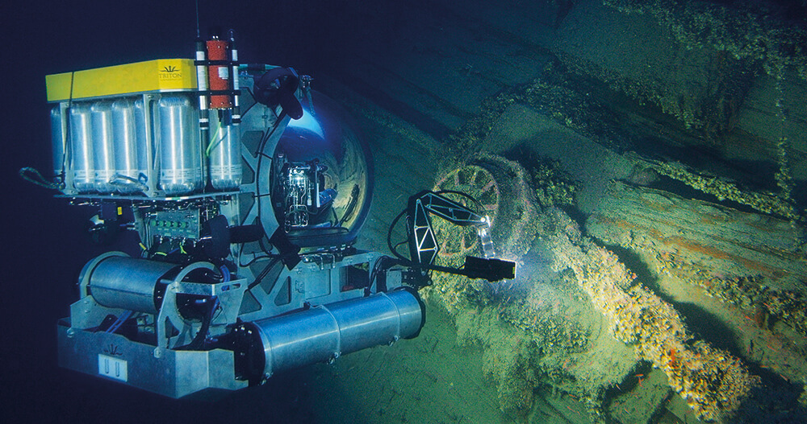The Triton 3300 one-person submarine is depth-rated to 1,000m and has a viewing sphere made of optical glass perfect for capturing film footage, as seen here on the wreck of HMHS Britannic in Greece. Photo: U Boat Malta
Underwater explorers reveal how breakthroughs in technology are changing marine archaeology. Report by Louise Murray
Advances in underwater technologies have ushered in a golden age of exploration and discovery, complementing the classic research and detective work skills necessary to find long-lost wrecks, and helping to make our marine heritage accessible to all. ‘As the technology develops, becoming cheaper and more reliable, the challenge for us archaeologists is to think of more creative and ambitious applications for it,’ says Dave Conlin, head of the Submerged Resources Centre at the US National Park Service (NPS).
Conlin and Evan Kovacs have worked together on many projects over the years, from the Titanic, to a sunken Second World War bomber lost on a secret mission during the Cold War, and the ancient Antikythera Greek shipwreck. Kovacs is CEO of Marine Imaging Technologies and Director of Underwater Photography at the Woods Hole Oceanographic Institution (WHOI). Last year saw another collaboration between the two friends in Hawaii. The USS Arizona was sunk on 7 December 1941 by the Japanese at Pearl Harbor, and 1,177 sailors and marines lost their lives that day. The iconic naval wreck is a designated war grave and off limits to divers. It is shallow, breaking the surface in the middle of the US Naval Base. The interior in its present condition has never been accurately mapped, and oil-leaking bunkers make checking on its structural condition imperative. ‘NPS is responsible for monitoring the wreck. We had to get inside to see what was going on in there,’ says Conlin. ‘With a conventional remotely-operated vehicle or ROV, the drag of the tether supplying power and controls would quickly exceed the ability of the thrusters to move it around inside a wreck interior. We went to our partners and collaborators with a problem and WHOI and Marine Imaging came back with a solution.’
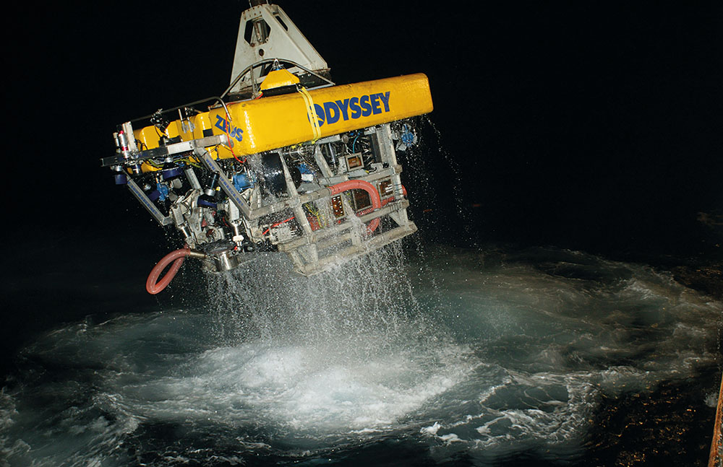
The ZEUS ROV often works extended hours. Photos: from Odyssey Marine Exploration Inc
The 11th Hour ROV – so-called because, like many cutting-edge technologies, it only worked as the developers neared their deadline – is a robotic ‘game changer’ according to Conlin. Kovacs is the head designer of the ROV that pays out its own tether as it enters a complex structure and reels it in as it returns, a bit like a cave diver with a reel. ‘The interior of the Arizona is similar to the Mexican cenotes. Stalactites hang down from the ceilings,’ says Kovacs, ‘one fell down and jammed in the thruster, trapping the ROV, but because it had an onboard tether reel it could haul itself out of trouble. Using a 4K camera with 3D capabilities allows us to accurately document the interior. We have to have this to make baseline volumetric models of the interior spaces of the wreck to monitor deterioration over time.’ The small robot was also equipped with a battery of scientific sensors and discovered crucial information, such as that deeper into the ship, the environment is anoxic – a zero, or low-oxygen environment.
Kovacs’ first foray into ROV design was in 2016 when he built Pixel, a high-end cinematographic platform that can carry any of today’s top-end film cameras plus the lighting system necessary for the best results.
‘Pixel also looks great,’ says Kovacs, ‘which is important in filming where the robot often becomes a character in a documentary. Our first Pixel is a 350m vehicle but we are working on one that will go to 4,500m. It will be able to work from a garage on a larger robot submersible or be taken into an area and launched from an autonomous vehicle. Pixel can be deployed anywhere in the world as we’ve designed it to be shipped in 15-20 flyable Pelican cases rather than the usual sea container, making it far more versatile and quicker to move around the planet.’
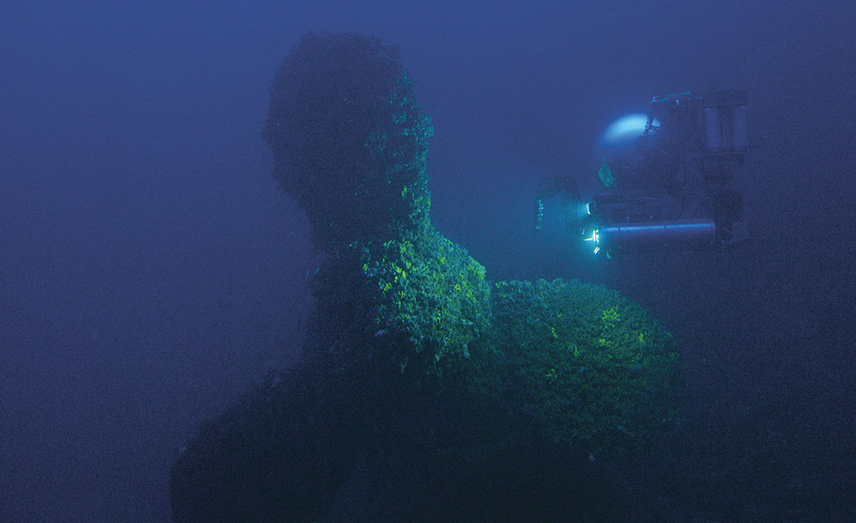
The Triton 3300 submersible approaches the Britannic’s propeller at a depth of around 120m. Photo: U Boat Malta
Pixel was instrumental in discovering the wreck of the USS Senator in the Great Lakes recently, filming its cargo of 268 Nash automobiles that were lost along with ten of the 28 crew in 1929.
Pixel and the 11th Hour are relatively small ROVs compared to the ZEUS used by Odyssey Marine Exploration for its work at extreme depths. An eight-tonne ROV highly customised for deep-sea exploration, ZEUS is piloted by two people, one who flies the robot and the other who manipulates the two powerful arms. Both pilots work under the direction of the project marine archaeologist. ZEUS also has a silicone ‘sucker’ which allows it to pick up delicate objects such as gold coins and jewellery or even glass spectacles. Very delicate items such as glass photographic plates or gold jewellery and coins are placed by the limpet into a drawer on ZEUS containing a proprietary gel that protects them from abrasion and any minute damage to the surfaces on their way back up to the recovery vessel.
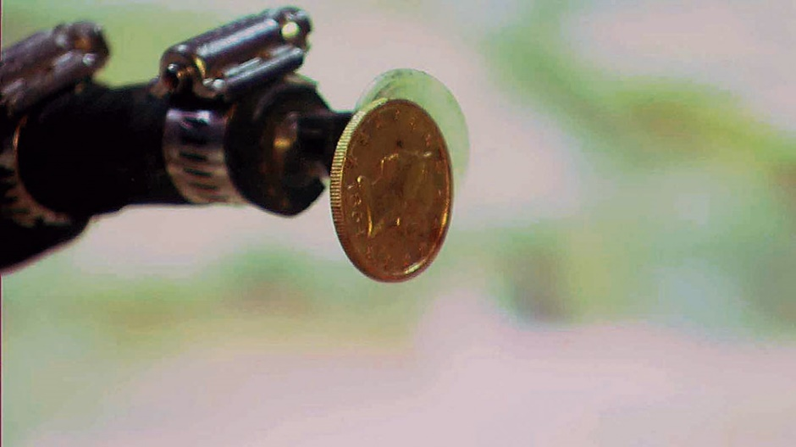
The limpet attached to ZEUS’ manipulator arm retrieves one of the 51,000 coins excavated from the SS Republic wreck site
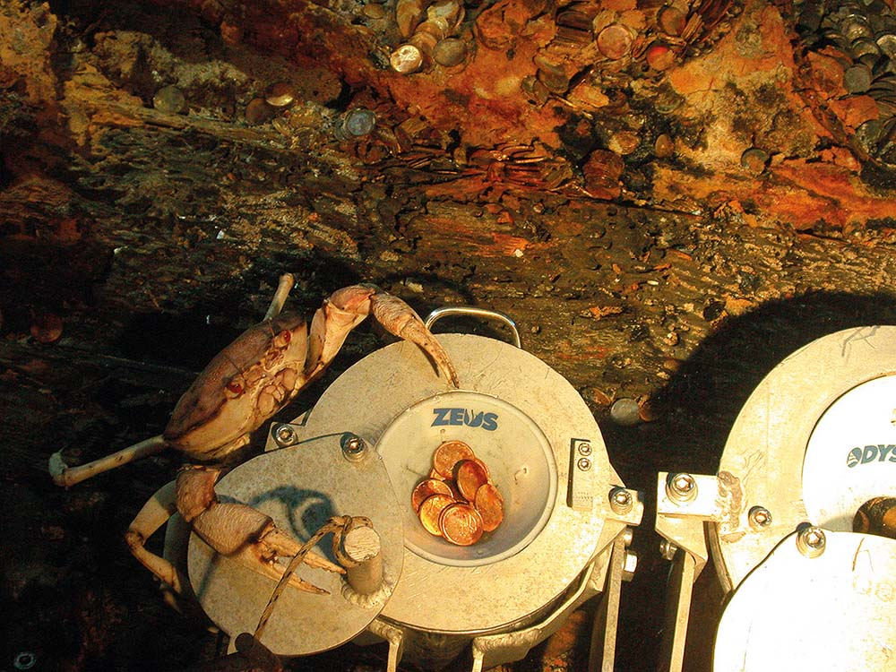
An inquisitive crab climbs aboard the recovery container
Coupling the ZEUS’s inertial navigation systems with acoustic positioning (where the robot references its position relative to pre-sunk transponder beacons) results in positioning correct to within centimetres. Pre-programming a set flight pattern, say to scan an area using accurate survey lines, or flying close to delicate areas on old wooden wrecks, all becomes possible and has completely changed how these vehicles are used underwater. ‘It’s a real game-changer,’ says Irishman Andrew Craig, Director of Marine Operations for the company, echoing Dave Conlin’s words. ‘The pilot has such an improved awareness of where the vehicle is in three dimensions. For years you’d be driving in a straight line but have location info that could jump around by as much as 10 metres – it made it difficult even to make a proper map! Now we can repeatedly return to exactly the same spot, even in zero visibility.’
Odyssey is well known for its recovery of gold and silver from the Gold Rush era paddle steamer SS Central America lying at 2,200m, and of 110 tonnes of silver from the SS Gairsoppa lying in 4,700m. Craig was in charge of both operations. The former mechanical engineer says, ‘Working on shipwrecks is one of the most fascinating jobs around. Accomplishing things once thought impossible, and seeing objects that have been lost for hundreds of years is very rewarding.’ Craig and his team of 42 work aboard recovery vessels equipped with advanced technology and capable of operation 24/7. He is unable to tell us about Odyssey’s current project due to commercial sensitivities, only saying that it is a wreck, and in ‘extremely’ deep water.
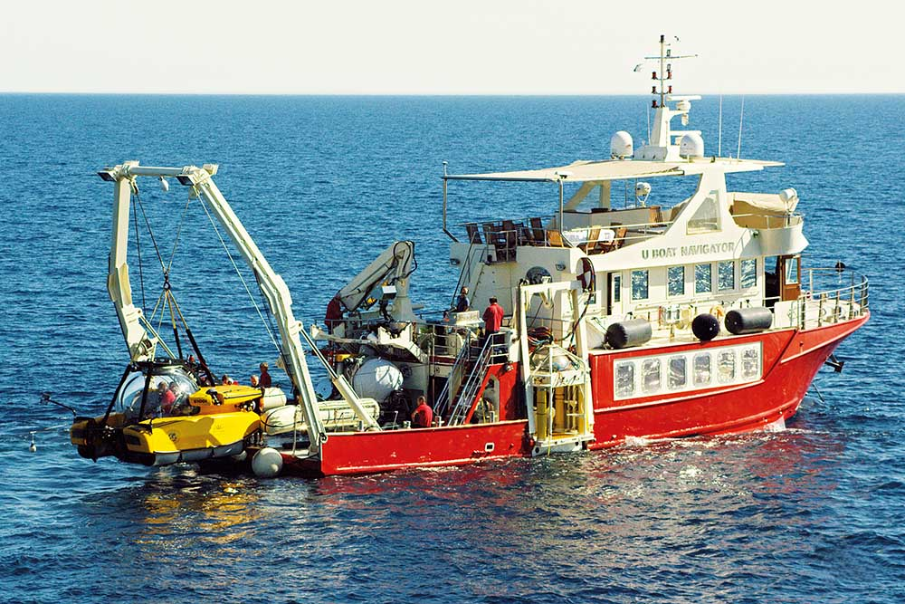
The team’s support vessel, seen here with the Triton submarine launch gantry at the stern. Photo: U Boat Malta
The search phase of looking for shipwrecks has changed a lot in the past decade, says Craig, ‘Ten to 15 years ago, if you wanted to find a wreck in 400m-plus depth, you’d tow a side-scan sonar behind your vessel – on maybe 10km of cable. You had to guesstimate where it was behind you using a layback calculation. Then, if you found something, it might take many additional passes to lock down the location. Now, with advances in acoustic technology, we can send a positioning signal from the towfish, to the mothership, that pinpoints its location to within 10m. It’s all much more efficient and faster to cover a large search box, therefore much cheaper, relatively speaking.’ The sonar tech itself has improved to the point where it is possible to see in ultra-high resolution a kilometre either side of the towfish or AUV (Autonomous Underwater Vehicle).
At less challenging depths is the largest civilian shipwreck in the world – the HMHS Britannic, sister ship to the Titanic. The wreck lies in 120m of water just inside the depth limits for exploration by human divers. She was sunk by a German mine in the Kea Channel in Greece in November 1916. ‘Britannic lies in that sweet spot where we can use technical divers, remotely operated vehicles and two Triton manned submersibles working in concert to explore the exterior of the ship. The 2016 expedition pretty much completed what we need in terms of exterior surveys,’ says British film-maker and maritime historian Simon Mills who owns the UK Government’s legal title to the wreck.
Dmitri Tomashov, 27, is one of the Triton sub pilots. He has been visiting and filming the Britannic for a documentary series since 2013. He says: ‘Our main goal is filming and surveying the whole ship, so both subs are equipped with 6K Red Dragon cameras and powerful LED lighting, the secret to high-quality underwater filming at depth.’ The addition of the second Triton means the team has an added element of safety, and of course, each Triton can film the other working, or shoot the same subject simultaneously from two different angles. Another advantage of these Tritons, which are depth-rated to 1,000m, is the viewing sphere made of optical glass, which allows filming at desirable angles without distorting the image. ‘There is nothing else out there right now that can outperform the Tritons,’ says Tomashov, ‘I can be in the water for seven or eight hours at a time, though there is a limit because concentration has to be absolute, and over time you do get pretty exhausted, even though comfort for both the pilot and the passengers is at a high level in these machines.’ The one-person Triton can deploy a tiny ROV of its own for close inspection of particular areas that the subs are too large to approach.
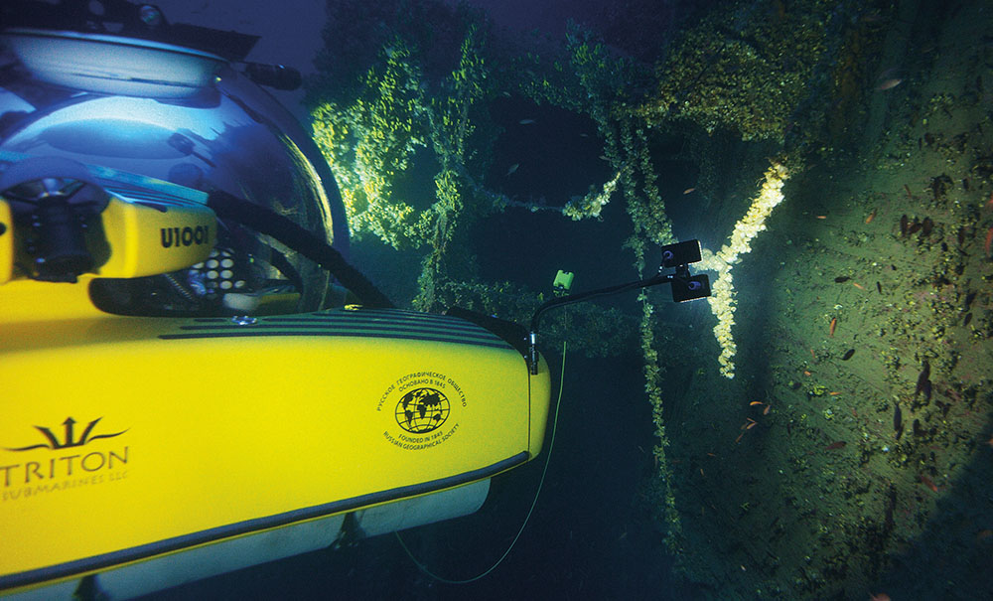
The Triton subs are equipped with 6K Red Dragon cameras and powerful LED lighting. Photo: U Boat Malta
Kovacs is also a member of the technical diving team on Britannic. He has repeatedly dived on the Britannic, ‘She is a magnificent ship, beautiful to look at and massive in all ways, and unlike the Titanic she is almost intact,’ he says. All diving is done on closed-circuit rebreathers which emit virtually no exhaust gas. This is important for the next stage of exploration inside the wreck. Bubbles, or pools of exhaled gases, would disrupt the delicate marine ecology of the interior, speeding up the degradation of fragile wood panelling, for example. The depth is near the limit for even experienced technical divers, and their time at the bottom is limited to 40 minutes or so. Even that short dive time on a gas mix of helium, oxygen and nitrogen requires a slow decompression of over five hours to reach the surface safely. ‘One of the big advantages for the divers and image-makers was the presence of a wet bell. This is a platform with a breathable air bubble supplied with hot water and communications from the surface. We can pump down unlimited gases to a diver in distress, which is a huge safety bonus. Plus, it’s easy to keep hydrated, and to be able to eat and listen to our iPods during the long hours of decompression is just great; the only thing missing is a cup of hot tea,’ he jokes.
Looking to the future, Simon Mills added, ‘The next phase is to enter the wreck with the permission and cooperation of the Greek government, and retrieve and conserve selected artefacts by deploying small ROVs and manned dives.’
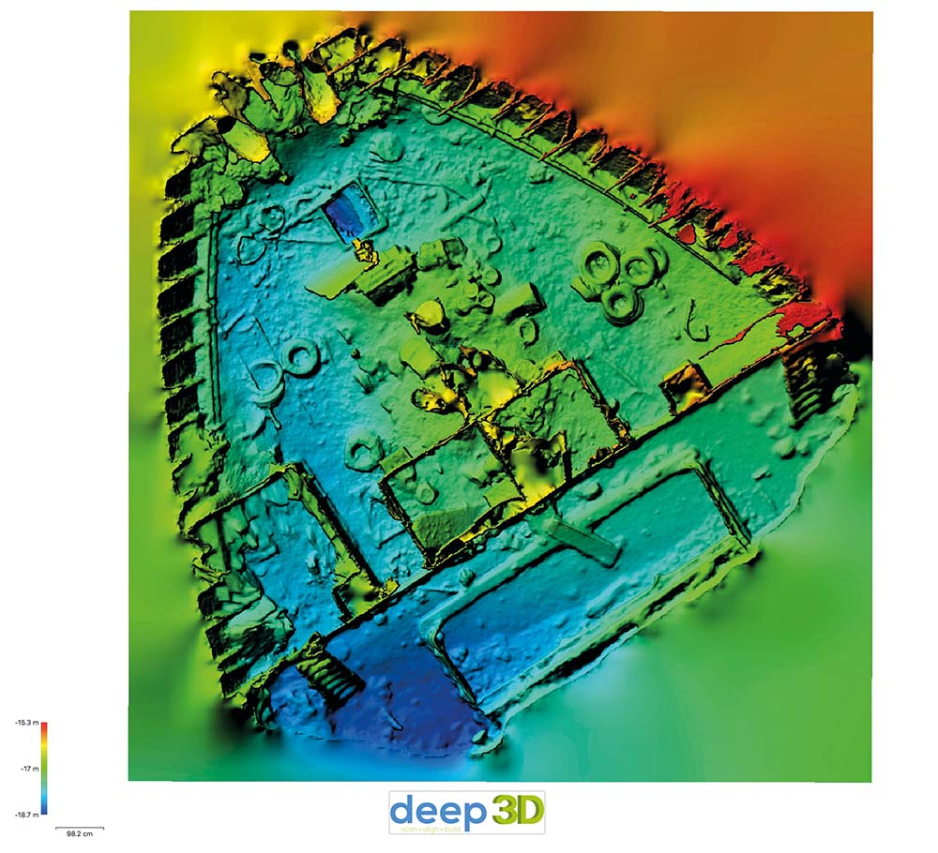 Accurate 3D modelling of the wreck of SS Thistlegorm will enable the team to monitor any changes in the wreck. Image: Simon Brown/www.deep3d.co.uk
Also receiving the hi-tech treatment is the much-loved wreck of the Thistlegorm, in the Egyptian Red Sea. Concerned about damage caused by the multitude of dive boats mooring directly onto unsuitable parts of the superstructure, the Egyptian authorities and the Universities of Nottingham and Alexandria spent five days this summer creating a virtual 3D scale model of the Thistlegorm to use as a baseline for any future deterioration. Simon Brown of Deep3D used a customised scooter to take 24,307 high-resolution pictures over 12 dives on the seven-acre site, ‘I could have swum it, but I’m sure that we would have needed much more time. Other team members collected the GPS data and made physical measurements that were used to ground truth the draft virtual model built on site. The manual measurements are important so that we can verify that the software-generated 3D model is accurate to a centimetre scale.’ Wear on the prop shaft is already evident where 5cm of metal has eroded due to attached ropes and lines. The new model enables the team to monitor any changes in the wreck from now on, including all but the smallest of the interior spaces.
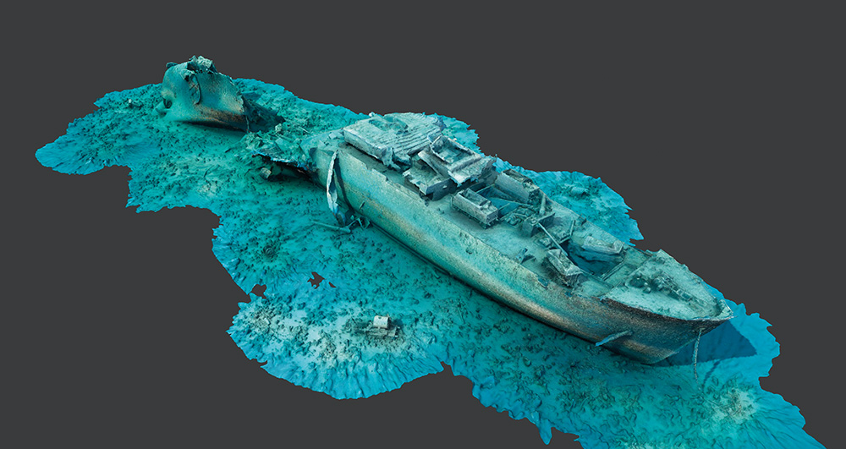
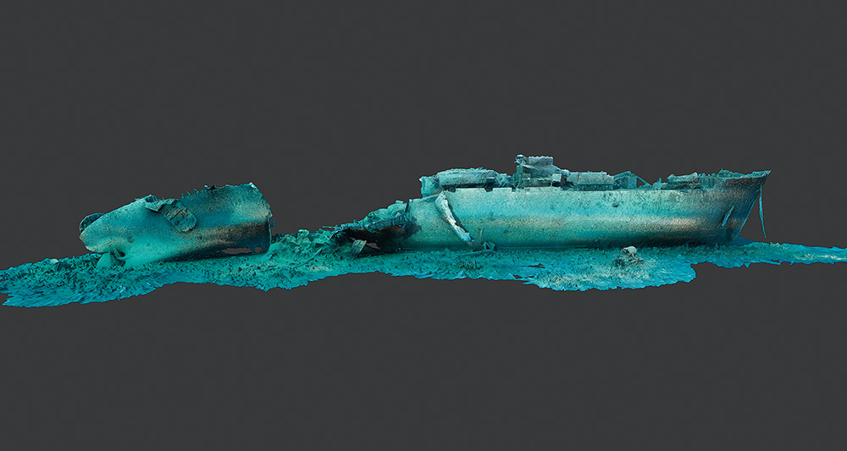
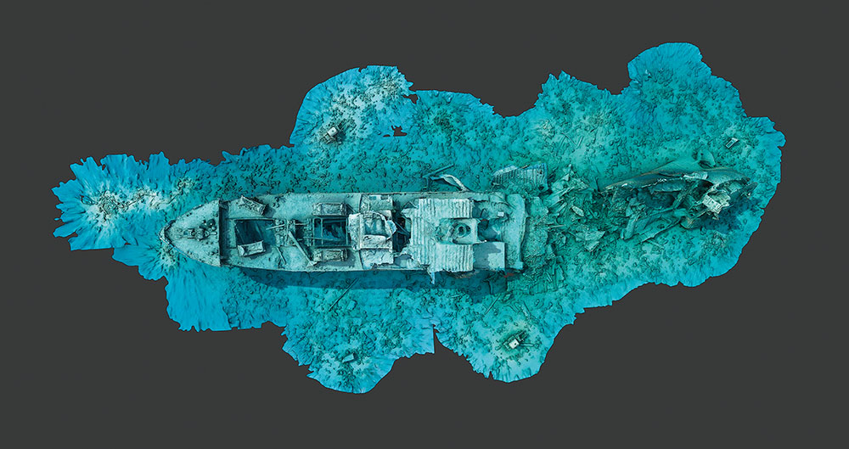
Software generated 3D models of the Thistlegorm were created from 24,307 high-resolution pictures taken over 12 dives on the 7-acre site.Above three images: thethistlegormproject.com
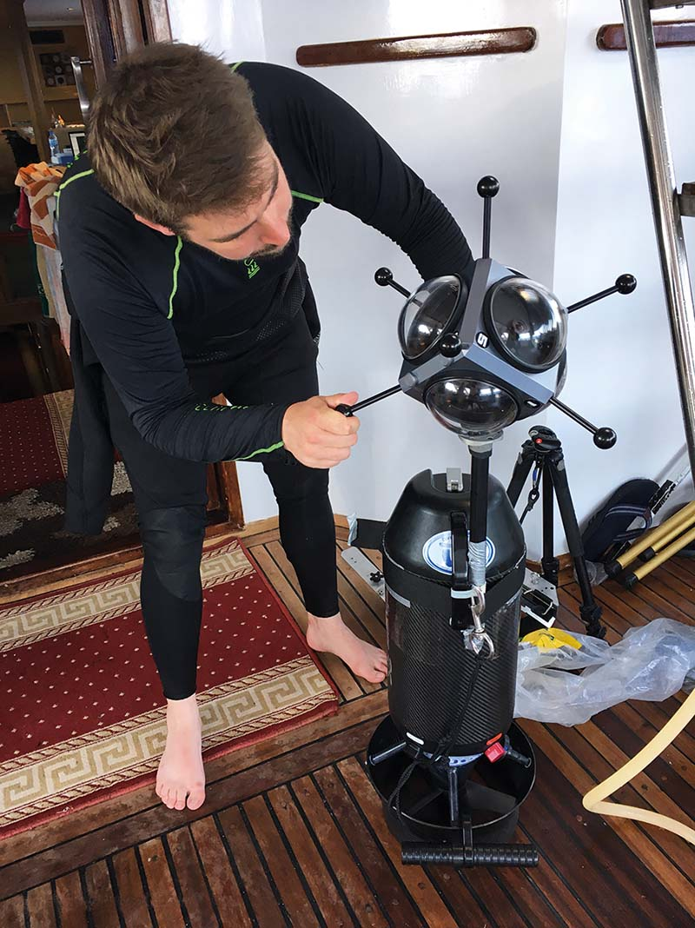
Prepping a video camera
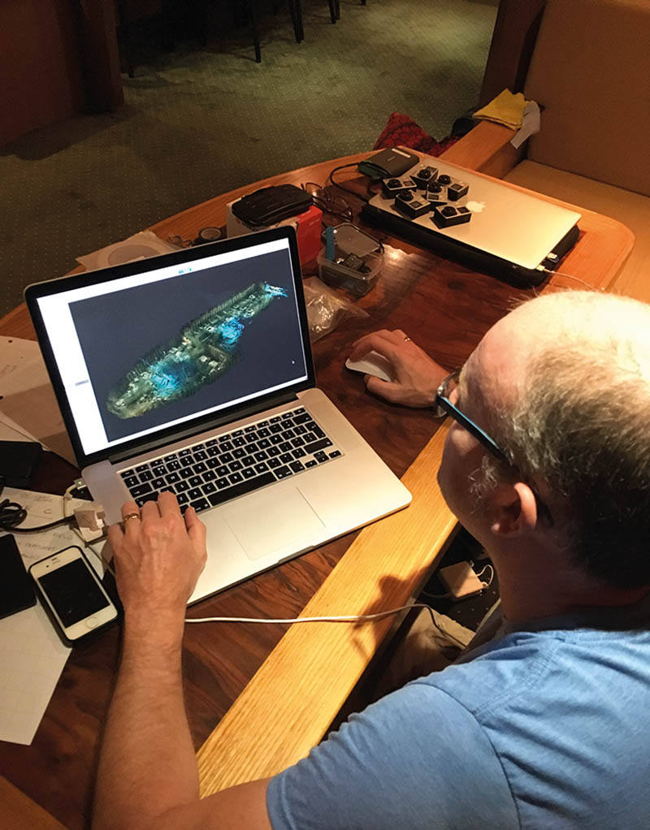Reviewing the 3D models
After almost 170 years of searching remote Arctic waters, the lost ship of British Polar explorer Sir John Franklin, the Erebus, was finally found in 2014. Jonathan Moore, underwater archaeologist at Parks Canada was part of the search team who had been looking for the ships since 2008. ‘We knew within minutes that it was either the Erebus or the Terror [the other vessel on the expedition]. The high-resolution side-scan sonar images produced measurements that matched plans held at the National Maritime Museum in Greenwich, and a couple of guns were later visible, so it was definitely a wreck of a 19th-century naval vessel,’ said Moore, who dived on the wreck during the following days, raising the ship’s bell. ‘A Seaeye Falcon ROV was sent down to take initial videos, followed by us divers. There is really no substitute for eyes on the wreck,’ he said. Returning to the vicinity of King William Island in 2015 the team was lucky enough to be part of a large Canadian Armed Forces exercise in the area. In April the sea is frozen, covered with 2m-thick ice, so team members dived through a hole cut into the ice and covered it with a tent. The team was able to recover the cannon and other artefacts. A giant Hercules C130 cargo plane on skis, landing on an ice runway nearby, made it possible to remove these artefacts. Some can be seen in the National Maritime Museum in Greenwich as part of an exhibition about the Franklin expedition.
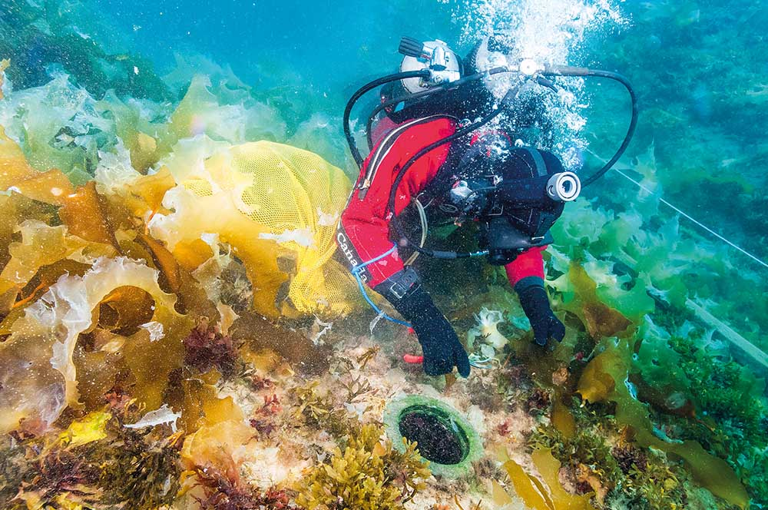
A diver on HMS Erebus. Photo: Parks Canada/Marc-André Bernier
‘We also left current meters and a tide gauge on the bottom for pickup the following season – as you can imagine there are no tide tables for these remote areas, the data helps us with our dive planning,’ says Moore.
In 2015 the team trialled the use of an underwater laser scanning system developed by 2G Robotics for the oil and gas industry to map the exterior and interior of the ship. It will return in 2018 and be used to map the cabin interiors in immense detail, down to the nails in the bulkheads. Moore’s job was to insert a small DeepTrekker ROV into a collapsed area of the stern which includes Franklin’s cabin and those of other senior officers. The team believes that this area may hold some of the answers to what happened to the ships and their crews. ‘The big pictures, of course, is well understood – everyone dies. But how the ships got to King William Island, and who was on board, if anyone. Those are the questions that we might be able to answer,’ says Moore. The scientists are all trained to professional commercial diving standards and will be much more comfortable next year, diving in hot-water suits to extend their dive times in the freezing waters. A support vessel, and an on-site hyperbaric chamber will offer added safety.
Whether it’s a tiny robot like the 11th Hour, a three-person submarine, or sonar and 3D imagery of wrecks, technology is helping marine archaeologists bring our underwater cultural heritage to life for the diver and non-diver alike, through virtual dives and exhibitions.
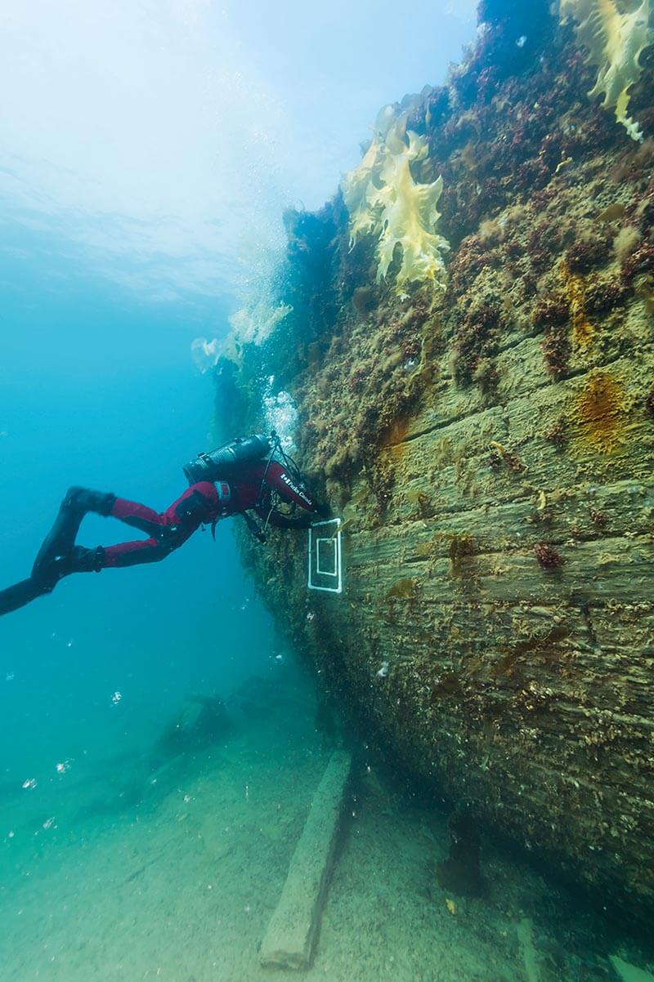
An archaeologist collects samples from the 19th-century naval vessel HMS Erebus found near King William Island, Canada. Photo: Parks Canada/Thierry Boyer

