Marine Steam Engines
Figure 1: Period cutaway diagram of a triple-expansion steam engine installation, circa 1918. This particular diagram illustrates possible engine cutoff locations, after the Lusitania disaster and others made it clear that this was an important safety feature.
Contents
History 2
Types of marine steam engine 2
Engines classified by connection mechanism 3
Side-lever 3
Grasshopper 4
Crosshead (square) 4
Walking beam 5
Steeple 6
Siamese 6
Direct acting 7
Oscillating 7
Trunk 8
Vibrating lever 8
Back acting 9
Vertical 9

History
The first commercially successful steam engine was developed by Thomas Newcomen in 1712. The steam engine improvements brought forth by James Watt in the later half of the 18th century greatly improved steam engine efficiency and allowed more compact engine arrangements. Successful adaptation of the steam engine to marine applications in England would have to wait until almost a century later after Newcomen, when Scottish engineer William Symington built the world's "first practical steamboat", the Charlotte Dundas, in 1802.[1] In 1807, the American Robert Fulton built the world's first commercially successful steamboat, simply known as the North River Steamboat, and powered by a Watt engine.
Following Fulton's success, steamboat technology developed rapidly on both sides of the Atlantic. Steamboats initially had a short range and were not particularly seaworthy due to their weight, low power, and tendency to break down, but they were employed successfully along rivers and canals, and for short journeys along the coast. The first successful transatlantic crossing by a steamship occurred in 1819 when Savannah sailed from Savannah, Georgia to Liverpool, England. The first steamship to make regular transatlantic crossings was the sidewheel steamer Great Western in 1838.[2]
As the 19th century progressed, marine steam engines and steamship technology developed alongside each other. Paddle propulsion gradually gave way to the screw propeller, and the introduction of iron and later steel hulls to replace the traditional wooden hull allowed ships to grow ever larger, necessitating steam power plants that were increasingly complex and powerful.[3]

Types of marine steam engine
A wide variety of reciprocating marine steam engines were developed over the course of the 19th century. The two main methods of classifying such engines are by connection mechanism and cylinder technology.
Most early marine engines had the same cylinder technology (simple expansion, see below) but a number of different methods of supplying power to the crankshaft (i.e. connection mechanism) were in use. Thus, early marine engines are classified mostly according to their connection mechanism. Some common connection mechanisms were side-lever, steeple, walking beam and direct-acting (see following sections).
However, steam engines can also be classified according to cylinder technology (simple-expansion, compound, annular etc.). One can therefore find examples of engines classified under both methods. An engine can be a compound walking beam type, compound being the cylinder technology, and walking beam being the connection method. Over time, as most engines became direct-acting but cylinder technologies grew more complex, people began to classify engines solely according to cylinder technology.
More commonly encountered marine steam engine types are listed in the following sections. Note that not all these terms are exclusive to marine applications.

Engines classified by connection mechanism

Side-lever
The side-lever engine was the first type of steam engine widely adopted for marine use in Europe.[4][5] In the early years of steam navigation (from c1815), the side-lever was the most common type of marine engine for inland waterway and coastal service in Europe, and it remained for many years the preferred engine for oceangoing service on both sides of the Atlantic.[6]
The side-lever was an adaptation of the earliest form of steam engine, the beam engine. The typical side-lever engine had a pair of heavy horizontal iron beams, known as side levers, that connected in the centre to the bottom of the engine with a pin. This connection allowed a limited arc for the levers to pivot in. These levers extended, on the cylinder side, to each side of the bottom of the vertical engine cylinder. A piston rod, connected vertically to the piston, extended out of the top of the cylinder. This rod attached to a horizontal crosshead, connected at each end to vertical rods (known as side-rods). These rods connected down to the levers on each side of the cylinder. This formed the connection of the levers to the piston on the cylinder side of the engine. The other side of the levers (the opposite end of the lever pivot to the cylinder) were connected to each other with a horizontal crosstail. This crosstail in turn connected to and operated a single connecting rod, which turned the crankshaft. The rotation of the crankshaft was driven by the levers—which, at the cylinder side, were driven by the piston's vertical oscillation.[7]
The main disadvantage of the side-lever engine was that it was large and heavy.[5] For inland waterway and coastal service, lighter and more efficient designs soon replaced it. It remained the dominant engine type for oceangoing service through much of the first half of the 19th century however, due to its relatively low centre of gravity, which gave ships more stability in heavy seas.[6] It was also a common early engine type for warships,[8] since its relatively low height made it less susceptible to battle damage. From the first Royal Navy steam vessel in 1820 until 1840, 70 steam vessels entered service, the majority with side-lever engines, using boilers set to 4psi maximum pressure.[8] The low steam pressures dictated the large cylinder sizes for the side-lever engines, though the effective pressure on the piston was the difference between the boiler pressure and the vacuum in the condenser.
The side-lever engine was a paddlewheel engine and was not suitable for driving screw propellers. The last ship built for transatlantic service that had a side-lever engine was the Cunard Line's paddle steamer RMS Scotia, considered an anachronism when it entered service in 1862.[9]
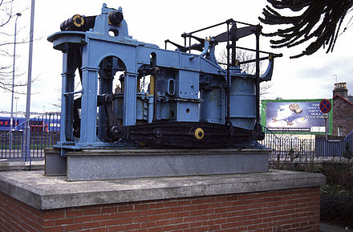
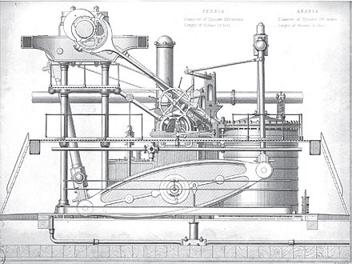
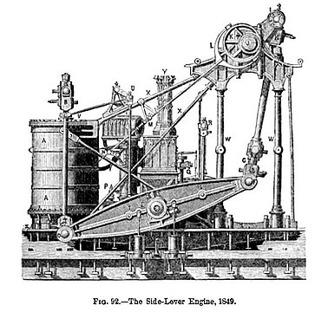
Figure 2: Early Napier side-lever engine from PS Leven, on display at Dumbarton, Scotland
Figure 3: Side-lever engine of RMS Persia (1855)
Figure 4: Side-lever engine of SS Pacific (1849)

Grasshopper
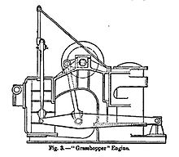
The grasshopper or 'half-lever'[10] engine was a variant of the side-lever engine. The grasshopper engine differs from the conventional side-lever in that the location of the lever pivot and connecting rod are more or less reversed, with the pivot located at one end of the lever instead of the centre, while the connecting rod is attached to the lever between the cylinder at one end and the pivot at the other.[11]
Figure 5: Diagram of a grasshopper engine
Chief advantages of the grasshopper engine were cheapness of construction and robustness, with the type said to require less maintenance than any other type of marine steam engine. Another advantage is that the engine could be easily started from any crank position. Like the conventional side-lever engine however, grasshopper engines were disadvantaged by their weight and size. They were mainly used in small watercraft such as riverboats and tugs.[11]

Crosshead (square)
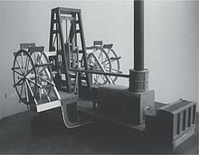
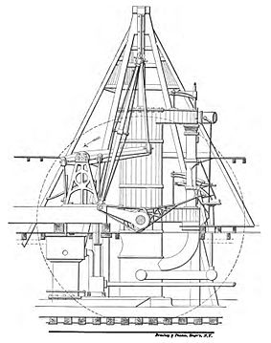
The crosshead engine, also known as a square, sawmill or A-frame engine, was a type of paddlewheel engine used in the United States. It was the most common type of engine in the early years of American steam navigation.[12]
Figure 6: Model of a crosshead or "square" engine, showing location of engine cylinder above the crankshaft; also piston rod, crosshead, connecting rods and paddlewheels
Figure 7: Diagram of a typical Hudson River steamboat crosshead engine (side view)
The crosshead engine is described as having a vertical cylinder above the crankshaft, with the piston rod secured to a horizontal crosshead, from each end of which, on opposite sides of the cylinder, extended a connecting rod that rotated its own separate crankshaft.[13] The crosshead moved within vertical guides so that the assembly maintained the correct path as it moved.[14] The engine's alternative name—"A-frame"—presumably derived from the shape of the frames that supported these guides. Some crosshead engines had more than one cylinder, in which case the piston rods were usually all connected to the same crosshead. An unusual feature of early examples of this type of engine was the installation of flywheels—geared to the crankshafts—which were thought necessary to ensure smooth operation. These gears were often noisy in operation.
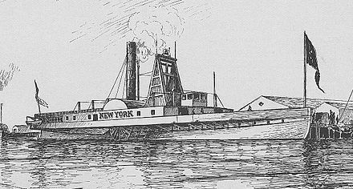
Because the cylinder was above the crankshaft in this type of engine, it had a high center of gravity, and was therefore deemed unsuitable for oceangoing service.[15] This largely confined it to vessels built for inland waterways.[13] As marine engines grew steadily larger and heavier through the 19th century, the high center of gravity of square crosshead engines became increasingly impractical, and by the 1840s, ship builders abandoned them in favor of the walking beam engine.[16]
Figure 8: The 1836 paddle steamer New York. Between the paddlewheels is the tall square or "A-frame" engine, within which can be seen the long piston rod, near the top of its stroke, making a "T" with the horizontal crosshead
The name of this engine can cause confusion, as "crosshead" is also an alternative name for the steeple engine (below). Many sources thus prefer to refer to it by its informal name of "square" engine to avoid confusion. Additionally, the marine crosshead or square engine described in this section should not be confused with the term "square engine" as applied to internal combustion engines, which in the latter case refers to an engine whose bore is equal to its stroke.

Walking beam
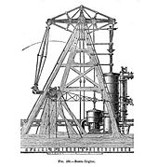
The walking beam, also known as a "vertical beam", "overhead beam", or simply "beam", was another early adaptation of the beam engine, but its use was confined almost entirely to the United States.[17] After its introduction, the walking beam quickly became the most popular engine type in America for inland waterway and coastal service, and the type proved to have remarkable longevity, with walking beam engines still being occasionally manufactured as late as the 1940s. In marine applications, the beam itself was generally reinforced with iron struts that gave it a characteristic diamond shape, although the supports on which the beam rested were often built of wood. The adjective "walking" was applied because the beam, which rose high above the ship's deck, could be seen operating, and its rocking motion was (somewhat fancifully) likened to a walking motion.
Figure 9: Basic diagram of a walking beam engine
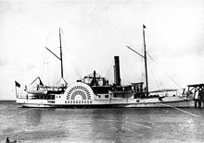
Walking beam engines were a type of paddlewheel engine and were rarely used for powering propellers. They were used primarily for ships and boats working in rivers, lakes and along the coastline, but were a less popular choice for seagoing vessels because the great height of the engine made the vessel less stable in heavy seas.[18] They were also of limited use militarily, because the engine was exposed to enemy fire and could thus be easily disabled. Their popularity in the United States was due primarily to the fact that the walking beam engine was well suited for the shallow-draft boats that operated in America's shallow coastal and inland waterways.[17]
Figure 10: USS Delaware (1861). The vessel's diamond shaped "walking beam" can clearly be seen amidships
Walking beam engines remained popular with American shipping lines and excursion operations right into the early 20th century. Although the walking beam engine was technically obsolete in the later 19th century, it remained popular with excursion steamer passengers who expected to see the "walking beam" in motion. There were also technical reasons for retaining the walking beam engine in America, as it was easier to build, requiring less precision in its construction. Wood could be used for the main frame of the engine, at a much lower cost than typical practice of using iron castings for more modern engine designs. Fuel was also much cheaper in America than in Europe, so the lower efficiency of the walking beam engine was less of a consideration. The Philadelphia shipbuilder Charles H. Cramp blamed America's general lack of competitiveness with the British shipbuilding industry in the mid-to-late 19th century upon the conservatism of American domestic shipbuilders and shipping line owners, who doggedly clung to outdated technologies like the walking beam and its associated paddlewheel long after they had been abandoned in other parts of the world.[19]
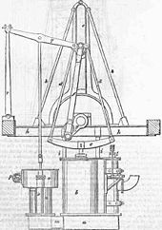
Figure 11: Steeple engine

Steeple
The steeple engine, sometimes referred to as a "crosshead" engine, was an early attempt to break away from the beam concept common to both the walking beam and side-lever types, and come up with a smaller, lighter, more efficient design. In a steeple engine, the vertical oscillation of the piston is not converted to a horizontal rocking motion as in a beam engine, but is instead used to move an assembly, composed of a crosshead and two rods, through a vertical guide at the top of the engine, which in turn rotates the crankshaft connecting rod below.[20] In early examples of the type, the crosshead assembly was rectangular in shape, but over time it was refined into an elongated triangle. The triangular assembly above the engine cylinder gives the engine its characteristic "steeple" shape, hence the name.
Steeple engines were tall like walking beam engines, but much narrower laterally, saving both space and weight. Because of their height and high centre of gravity, they were, like walking beams, considered less appropriate for oceangoing service, but they remained highly popular for several decades, especially in Europe, for inland waterway and coastal vessels.[21]
Steeple engines began to appear in steamships in the 1830s and the type was perfected in the early 1840s by the Scottish shipbuilder David Napier.[22] The steeple engine was gradually superseded by the various types of direct-acting engine.

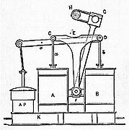
Siamese
Figure 12: Basic diagram of a Siamese engine
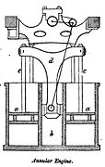
The Siamese engine, also referred to as the "double cylinder" or "twin cylinder" engine, was another early alternative to the beam or side-lever engine. This type of engine had two identical, vertical engine cylinders arranged side-by-side, whose piston rods were attached to a common, T-shaped crosshead. The vertical arm of the crosshead extended down between the two cylinders and was attached at the bottom to both the crankshaft connecting rod and to a guide block that slid between the vertical sides of the cylinders, enabling the assembly to maintain the correct path as it moved.[23]
Figure 13: Diagram of an annular engine (see below) with Siamese connection mechanism
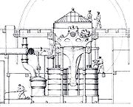
The Siamese engine was invented by British engineer Joseph Maudslay (son of Henry), but although he invented it after his oscillating engine (see below), it failed to achieve the same widespread acceptance, as it was only marginally smaller and lighter than the side-lever engines it was designed to replace.[24] It was however used on a number of mid-century warships, including the first warship fitted with a screw propeller, HMS Rattler.
Figure 14: Siamese engine of HMS Retribution (1844)

Direct acting
There are two definitions of a direct-acting engine encountered in 19th-century literature. The earlier definition applies the term "direct-acting" to any type of engine other than a beam (i.e. walking beam, side-lever or grasshopper) engine. The later definition only uses the term for engines that apply power directly to the crankshaft via the piston rod and/or connecting rod.[25] Unless otherwise noted, this article uses the later definition.
Unlike the side-lever or beam engine, a direct-acting engine could be readily adapted to power either paddlewheels or a propeller. As well as offering a lower profile, direct-acting engines had the advantage of being smaller and weighing considerably less than beam or side-lever engines. The Royal Navy found that on average a direct-acting engine (early definition) weighed 40% less and required an engine room only two thirds the size of that for a side-lever of equivalent power. One disadvantage of such engines is that they were more prone to wear and tear and thus required more maintenance.[24]

Oscillating
Main article: Oscillating cylinder steam engine
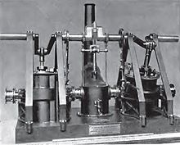
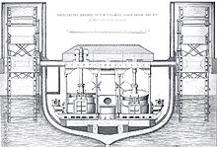
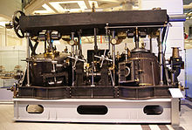
An oscillating engine was a type of direct-acting engine that was designed to achieve further reductions in engine size and weight. Oscillating engines had the piston rods connected directly to the crankshaft, dispensing with the need for connecting rods. To achieve this, the engine cylinders were not immobile as in most engines, but secured in the middle by trunnions that let the cylinders themselves pivot back and forth as the crankshaft rotated—hence the term, oscillating.[26]
Figure 15: Model of a Maudslay oscillating engine
Figure 16: Oscillating paddlewheel engines of HMS Black Eagle. Oscillating engines could be used to drive either paddlewheels or propellers.
Figure 17: Oscillating engine built in 1853 by J. & A. Blyth of London for the Austrian paddle steamer Orsova
Steam was supplied and exhausted through the trunnions. The oscillating motion of the cylinder was usually used to line up ports in the trunnions to direct the steam feed and exhaust to the cylinder at the correct times. However, separate valves were often provided, controlled by the oscillating motion. This let the timing be varied to enable expansive working (as in the engine in the paddle ship PD Krippen). This provides simplicity but still retains the advantages of compactness.
The first patented oscillating engine was built by Joseph Maudslay in 1827, but the type is considered to have been perfected by John Penn. Oscillating engines remained a popular type of marine engine for much of the 19th century.[26]

Trunk
The trunk engine, another type of direct-acting engine, was originally developed as a means of reducing an engine's height while retaining a long stroke. (A long stroke was considered important at this time because it reduced the strain on components.)
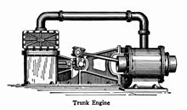
A trunk engine locates the connecting rod within a large-diameter hollow piston rod. This "trunk" carries almost no load. The interior of the trunk is open to outside air, and is wide enough to accommodate the side-to-side motion of the connecting rod, which links a gudgeon pin at the piston head to an outside crankshaft.
Figure 18: Trunk engine illustration
The walls of the trunk were either bolted to the piston or cast as one piece with it, and moved back and forth with it. The working portion of the cylinder is annular or ring-shaped, with the trunk passing through the centre of the cylinder itself.[27][28]
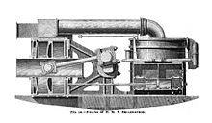
Early examples of trunk engines had vertical cylinders. However, ship builders quickly realized that the type was compact enough to lay horizontally across the keel. In this configuration, it was very useful to navies, as it had a profile low enough to fit entirely below a ship's waterline, as safe as possible from enemy fire. The type was generally produced for military service by John Penn.
Figure 19: Cutaway view of trunk engine of HMS Bellerophon, showing (on the left) engine cylinder, annular piston and trunk assembly, and connecting rod inside trunk
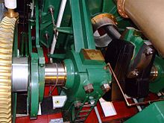
Trunk engines were common on mid-19th century warships.[28] They also powered commercial vessels, where—though valued for their compact size and low centre of gravity—they were expensive to operate. Trunk engines, however, did not work well with the higher boiler pressures that became prevalent in the latter half of the 19th century, and builders abandoned them for other solutions.[28]
Figure 20: Looking down at the trunk engine of HMS Warrior (1860). The connecting rod can be seen emerging from the trunk at right.
Trunk engines were normally large, but a small, mass-produced, high-revolution, high-pressure version was produced for the Crimean War. In being quite effective, the type persisted in later gunboats.[29] An original trunk engine of the gunboat type exists in the Western Australian Museum in Fremantle. After sinking in 1872, it was raised in 1985 from the SS Xantho and can now be turned over by hand.[30] The engine's mode of operation, illustrating its compact nature, could be viewed on the Xantho project's website.[31]
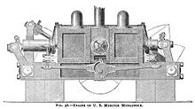
Figure 21: Vibrating-lever engine of USS Monadnock (1863) - front view

Vibrating lever

The vibrating lever, or half-trunk engine, was a development of the conventional trunk engine conceived by Swedish-American engineer John Ericsson. Ericsson needed a small, low-profile engine like the trunk engine to power the U.S. Federal government's monitors, a type of warship developed during the American Civil War that had very little space for a conventional powerplant.[32] The trunk engine itself was, however, unsuitable for this purpose, because the preponderance of weight was on the side of the engine that contaied the cylinder and trunk—a problem that designers could compensate for on the small monitor warships.
Ericsson resolved this problem by placing two horizontal cylinders back-to-back in the middle of the engine, working two "vibrating levers", one on each side, which by means of shafts and additional levers rotated a centrally located crankshaft.[32] Vibrating lever engines were later used in some other warships and merchant vessels, but their use was confined to ships built in the United States and in Ericsson's native country of Sweden,[33] and as they had few advantages over more conventional engines, were soon supplanted by other types.

Back acting
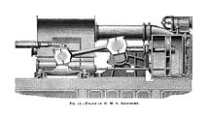
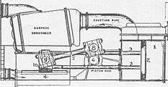
The back-acting engine, also known as the return connecting rod engine, was another engine designed to have a very low profile. The back-acting engine was in effect a modified steeple engine, laid horizontally across the keel of a ship rather than standing vertically above it.[33] Instead of the triangular crosshead assembly found in a typical steeple engine however, the back-acting engine generally used a set of two or more elongated, parallel piston rods terminating in a crosshead to perform the same function. The term "back-acting" or "return connecting rod" derives from the fact that the connecting rod "returns" or comes back from the side of the engine opposite the engine cylinder to rotate a centrally located crankshaft.[34]
Figure 22: Return connecting rod engine of HMS Agincourt (1865)
Figure 23: Diagram of back-acting engine of USS Ranger
Back-acting engines were another type of engine popular in both warships and commercial vessels in the mid-19th century, but like many other engine types in this era of rapidly changing technology, they were eventually abandoned for other solutions. There is only one known surviving back-acting engine—that of the TV Emery Rice (formerly USS Ranger), now the centerpiece of a display at the American Merchant Marine Museum.[35][36]
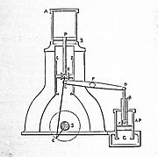
Figure 24: Diagram of a simple "hammer" engine

Vertical
As steamships grew steadily in size and tonnage through the course of the 19th century, the need for low profile, low centre-of-gravity engines correspondingly declined. Freed increasingly from these design constraints, engineers were able to revert to simpler, more efficient and more easily maintained designs. The result was the growing dominance of the so-called "vertical" engine[25] (more correctly known as the vertical inverted direct acting engine).
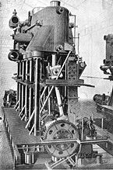
In this type of engine, the cylinders are located directly above the crankshaft, with the piston rod/connecting rod assemblies forming a more or less straight line between the two.[25] The configuration is similar to that of a modern internal combustion engine (one notable difference being that the steam engine is double acting, see below, whereas almost all internal combustion engines generate power only in the downward stroke). Vertical engines are sometimes referred to as "hammer", "forge hammer" or "steam hammer" engines, due to their roughly similar appearance to another common 19th-century steam technology, the steam hammer.[37]
Figure 25: Vertical triple-expansion engine of USS Wisconsin (BB-9). The typical vertical engine arrangement of cylinder, piston rod, connecting rod and crankshaft can clearly be seen in this photo.
Vertical engines came to supersede almost every other type of marine steam engine toward the close of the 19th century.[25][37] Because they became so common, vertical engines are not usually referred to as such, but are instead referred to based upon their cylinder technology, i.e. as compound, triple-expansion, quadruple-expansion etc. It should be noted that the term "vertical" for this type of engine is imprecise, since technically any type of steam engine is "vertical" if the cylinder is vertically oriented. An engine someone describes as "vertical" might not be of the vertical inverted direct-acting type, unless they use the term "vertical" without qualification.

From: https://en.wikipedia.org/wiki/Marine_steam_engine

