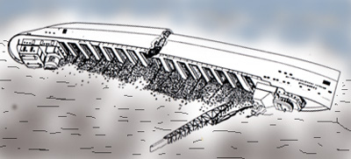
The Story & History of the SS Cedarville Shipwreck
A Composite of References
By: Wayne J. “Mike” Michaels
December 26, 2018

Table of Contents
Cedarville 2
History 2
Present Condition 3
Official Registrations 3
CEDARVILLE 3
HARVEY, A.F. 4
Registry and Rig Information 4
Dimensions and Tonnage 4
Vessel History 5
Maps of Cedarville Shipwreck (45 47.235'N 084 40.248'W) 6
SS Cedarville (Wikipedia) 7
Service history 7
Sinking 8
Wreck site 8
References 8
Images of the SS Cedarville 9

Cedarville
Depth: | 40′ to 110′
Dimensions: | 604′ x 60′ x 32′
Cargo: | Open-hearth limestone
Cause of Sinking: | Collision (in fog) with M.V. Topdalsfjord
Built: | 1927, River Rouge MI by Great Lakes Engineering
Date Lost: | May 7, 1965
Construction: | Steel
Propulsion: | Triple-expansion steam engine, 2200 hp
Skill Level: | Intermediate to Advanced
Location: | N45° 47.235′ W085° 40.248′

History
The Cedarville was launched in 1927 at River Rouge MI as the A.F. Harvey, a straight-deck bulk carrier for the Pittsburg Steamship Company (US Steel). She was 604 ft. long (588 ft keel) with a triple expansion steam engine. The vessel was transferred to the Michigan Limestone Division (Bradley Transportation Line) and converted to a self-unloader at Defoe Shipyard in Bay City MI over the winter of 1957-58.
In the early morning of May 7, 1965, the Cedarville departed Port Calcite, near Rogers City, headed to Gary, IN with 14,411 tons of limestone with a crew of 35. As they neared the Straits of Mackinac, the fog thickened. Due to a lack of communication, the Norwegian vessel Topdalsfjord collided with the Cedarville on her port side cutting a deep gash in her side between the seventh and eight hatch.
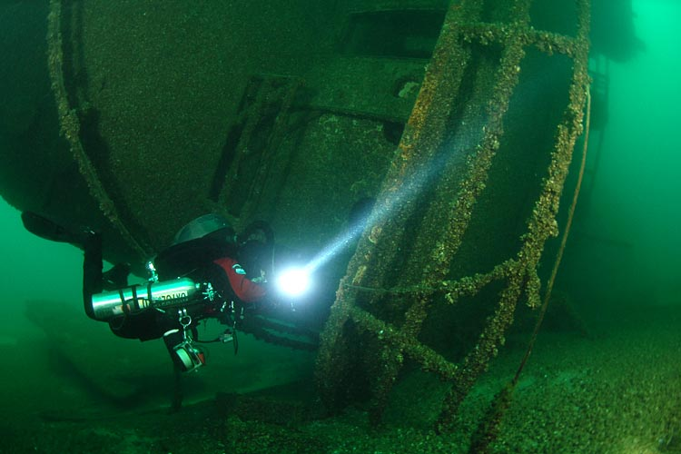
After briefly dropping anchor to consider the situation, the Cedarville’s Captain attempted to beach the vessel near Mackinaw City. While still several miles offshore, at 10:25 am the Cedarville suddenly rolled over to starboard and sank in 105 feet of water about 3.5 Miles SE of the Mackinac Bridge south tower. Twenty-five crewmen were recovered alive from the cold lake, along with two others that succumbed due to exposure, and eight others went down with the ship. All but one of the missing crewmen have been recovered, with one still listed as missing.

Present Condition
The Cedarville is a favorite site in the Straits of Mackinac. She is intact and lies on her starboard side, about 45 degrees from being upside down. Her massive size and inverted orientation makes for an interesting, but sometimes confusing dive. The cabins are visible along with lots of deck equipment and the fatal gash. Caution is warranted given her size, depth, upside down orientation and variable visibility. Many hazards are present and penetration should not attempted without proper training, experience, planning and equipment. Due to the orientation of the vessel to the currents, the visibility is often reduced to 35 ft or less but the ship still presents a great diving opportunity.

Official Registrations
CEDARVILLE
Other names : built as A.F. HARVEY, last name in 1957
Official no. : 226492
Type at loss : propeller, steel, self-unloading bulk freighter
Build info : 1927, Great Lakes Engineering, River Rouge, MI hull #255
Specs : 588x60x32 8575 g 6229n
Date of loss : 1965, May 7
Place of loss : 3 mi E of Mackinac Bridge, Straits
Lake : Huron
Type of loss : collision
Loss of life : 10
Carrying : limestone
Detail : Moving at speed in fog, she collided with the Norwegian freighter TOPDALSFJORD about 9:50 am and sank quickly. German motor vessel WEISSENBURG picked up the survivors. Wreck location: 3.1 mi, 120 deg from S pier of Mackinac Bridge. She was later found to be at fault in the collision. She is a popular dive target.
Built as a bulk freighter, she was converted to a self-unloader at Defoe Shipbuilding, 1957
Sources: eas,glp,is(3-65),slh,sol,ns5,lhdc,ssm,mpl,hcgl
From: http://www.boatnerd.com/swayze/shipwreck/c.htm

HARVEY, A.F.

Photos
- 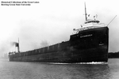
Description:
Date Taken:
Size: 8.75 x 5.88
Media: Print
Creator:
Collection: HCGL/MAIN: Lake Carriers' Assn.
Image ID: 002610

Registry and Rig Information
- Vessel Name: HARVEY, A.F.
- Nationality: U.S.
- Official Number: 226492
- Rig: Propeller

Dimensions and Tonnage
- Length: 588.25
- Width: 60.16
- Depth: 27.66
- Masts: 0
- Gross Tonnage: 7973.00
- Net Tonnage: 6352.00
- Hull Material: Steel
- Hull Number: 00255

Vessel History
- Rebuilds: Converted to self-unloader by Defoe Shipbuilding Co., Bay City, MI, winter, 1956-1957 (588.25 x 60.16 x 30.66; 8575 gross - 6229 net). Reboilered and received new stack at Rogers City, MI, 1961.
- History:
- Disposition: Sunk by collision with Norwegian propeller TOPDALSFJORD, May 7, 1965, in fog three miles east of Straits Bridge, Straits of Mackinac; ten lives lost.

Build Information
- Builder: Great Lakes Engineering Works
- Place Built: River Rouge, MI
- Year Built: 1927

Ownership Changes
Owner | Date | Registry | Official Number
Pittsburgh Steamship Co. | 1927 - 1952 | U.S. | 226492
U.S. Steel Corp. | 1952 - 1965 | U.S. | 226492

Name Changes
Name | Date | Registry | Official Number
CEDARVILLE | 1957 - 1965 | U.S. | 226492

From: http://greatlakes.bgsu.edu/vessel/view/003934

Maps of Cedarville Shipwreck (45 47.235'N 084 40.248'W)
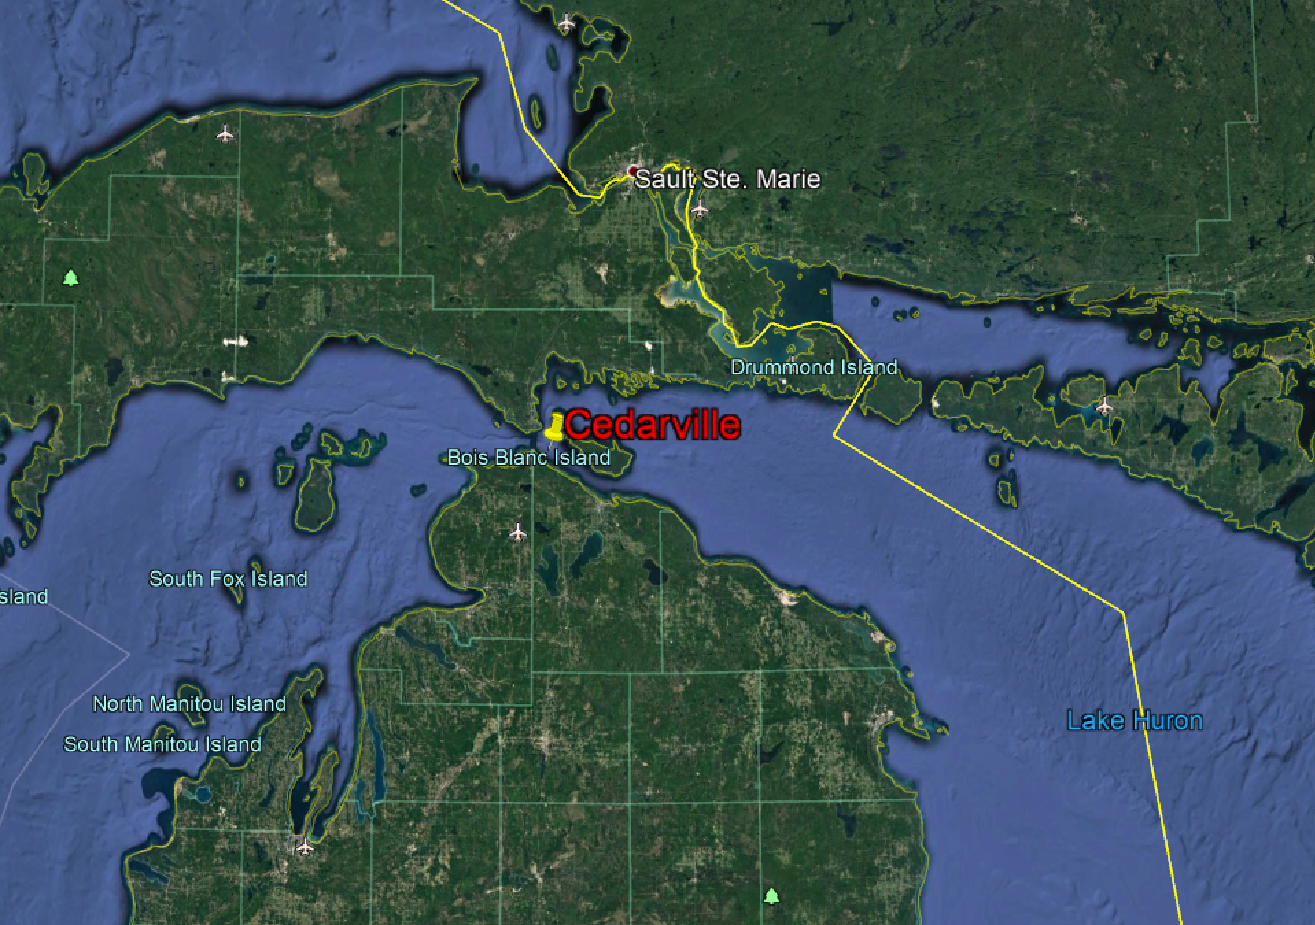
Figure 1 - Overview of Cedarville Wreck Site
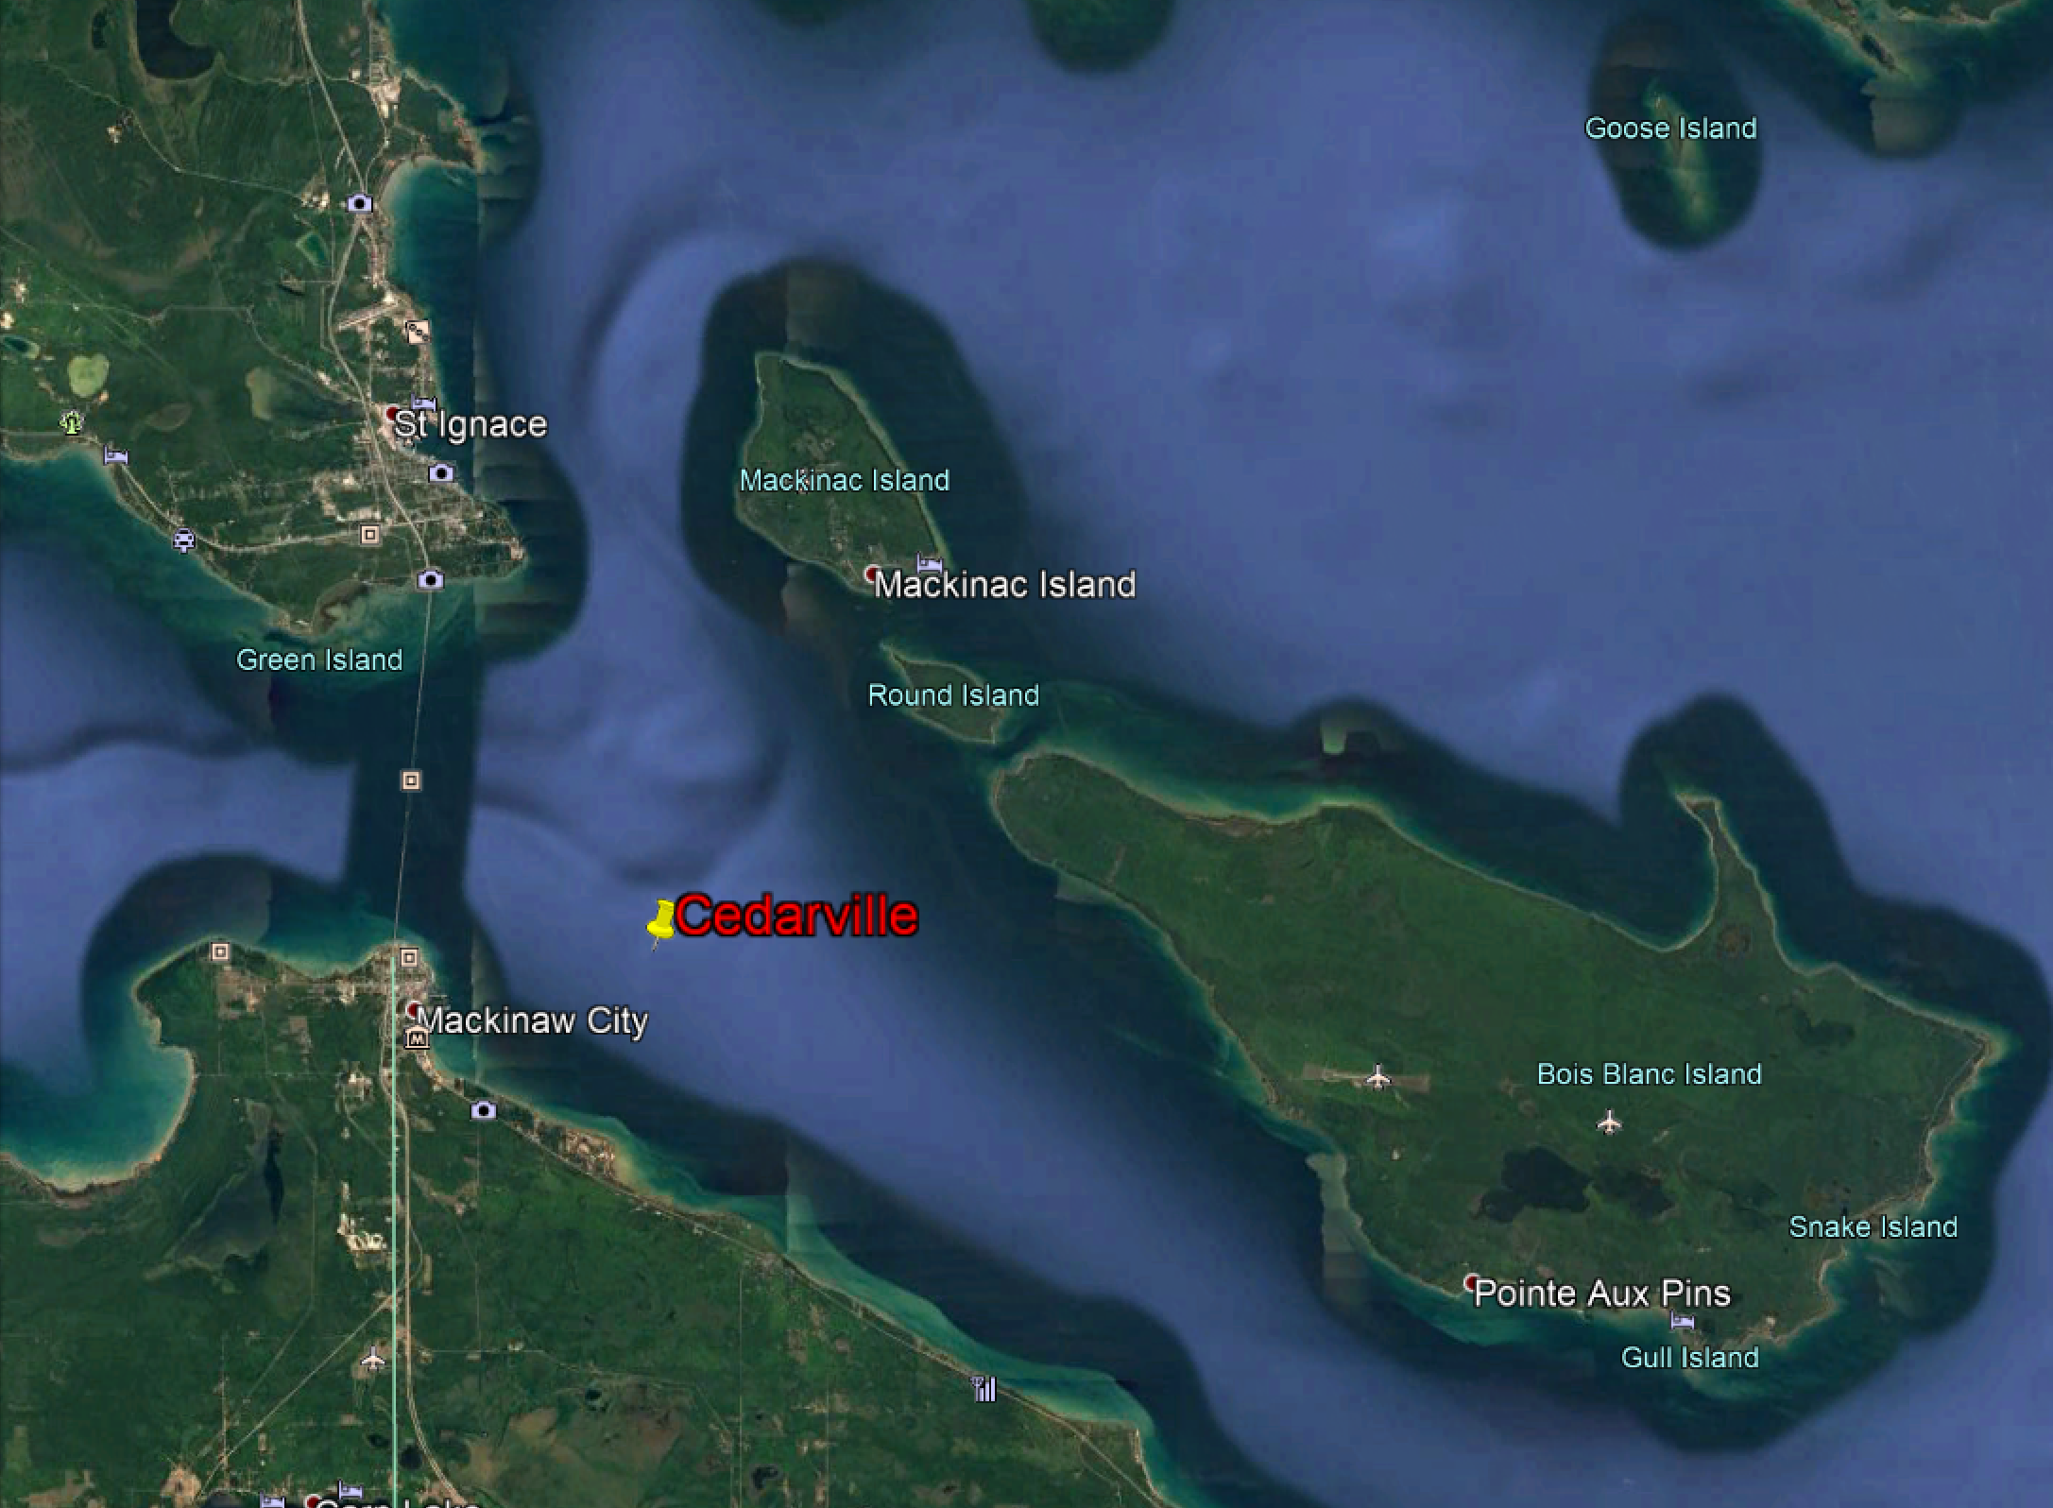
Figure 2 - Detail of Cedarville Wreck Site

SS Cedarville (Wikipedia)
From Wikipedia, the free encyclopedia
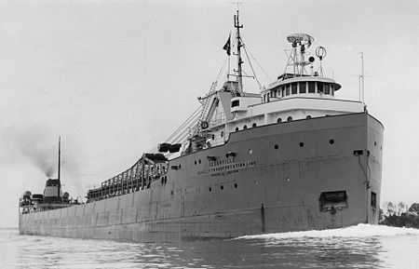  Figure 3 - The Cedarville underway | History  United States  Name: SS A.F. Harvey (1927-1957) SS Cedarville (1956-1965)  Owner: - Pittsburgh Steamship Company (1927-1956) - US Steel (1956-1965)  Builder: Great Lakes Engineering Works  In service: 1927  Out of service: 1965  Fate: Sank after collision 7 May 1965, 10 out of 35 crewmembers died  General characteristics  Tonnage: 8,575 gross tons^{[1]}  Length: 588.3 ft (179.3 m)^{[1]}  Beam: 60.2 ft (18.3 m)^{[1]}  Height: 30.8 ft (9.4 m)^{[1]}  Crew: 35^{[2]}

SS Cedarville was a bulk carrier that carried limestone on the Great Lakes in the mid-20th century until it sank after a collision with another ship, SS Topdalsfjord.

Service history
Cedarville was built in 1927 by the Great Lakes Engineering Works in River Rouge, Michigan. The ship was launched as the SS A.F. Harvey, and entered service for the Pittsburgh Steamship Company division of US Steel. In 1956, the ship was transferred to the Bradley Transportation Company, still owned by US Steel. As part of the transfer, the ship was converted to be a self-unloading vessel and was renamed Cedarville.

Sinking
On May 7,1965, Cedarville was travelling between Rogers City, Michigan^{[3]} and Gary, Indiana with a load of 14,411 tons of limestone.^{[2]} A mile east of the Mackinac Bridge, in heavy fog, Cedarville collided with the Norwegian ship SS Topdalsfjord. The collision occurred as a result of miscommunication between the two ships, which both changed their course a mile away from each other, with Topdalsfjord's captain steering his ship on a course that would lead to the two vessels passing each other on their starboard sides. The captain of Cedarville, however, intended for his vessel to cross the bow of Topdalsfjord, but his message stating such was not received by Topdalsfjord, which continued on a course that led to it colliding with Cedarville's port side.^{[1][2]}

While the collision caused only superficial damage above the waterline, consisting mainly of broken railings and deck plates, the bow of Topdalsfjord had created a large hole in Cedarville's hull below the waterline, and within minutes of the collision a slight list to the port had developed. The captain of Cedarville ordered water to be pumped into the starboard ballast tanks to counteract the list, and intended to try to run the ship aground to prevent it from sinking. As the ship moved towards land, however, the weight of the water within the hull forced the bow down, and the ship began listing to starboard, eventually rolling over before sinking. Most survivors of the collision, in which ten out of the 35 aboard died, were picked up by the German freighter MV Weissenburg, and subsequently transferred to the US Coast Guard cutter Mackinaw.^{[3]}

Inquiry into sinking

A U.S. Coast Guard inquiry into the incident found that the captain of Cedarville was at fault for the sinking and was charged with four counts of faulty seamanship. He initially pleaded innocent, but in August 1965 changed his plea to guilty. His license was suspended for a year as a result of the inquiry.^{[2]}

Wreck site
The wreck of Cedarville lies in the Straits of Mackinac Shipwreck Preserve in water around 110 feet (34 m) deep, although the highest point of the hull is around 35 feet (11 m) below the surface and the cabins of the ship are around 75 feet (23 m) underwater.^{[4]} Expert divers are able to enter the ship, as most parts remain fairly undamaged.^{[2]} The Cedarville is the fourth largest ship lost on the Great Lakes after the Edmund Fitzgerald, Daniel J. Morrell and sister ship Carl D. Bradley.

References
  - ^ Jump up to: ª ^{b} ^{c} ^{d} ^{e} Hancock, Paul (2001). Shipwrecks of the Great Lakes. PRC Publishing. ISBN 1-882376--84-6.
  - ^ Jump up to: ª ^{b} ^{c} ^{d} ^{e} "Sunday Marks 35th anniversary of wreck". Great Lakes Shipwreck Research. Retrieved 18 June 2010.
  - ^ Jump up to: ª ^{b} "Collision and Sinking of the S.S. Cedarville". MIGenWeb. Archived from the original on 4 March 2016. Retrieved 21 March 2018.
  - ^ "Straits of Mackinac Shipwreck Preserve". Michigan Underwater Preserves. Retrieved 1 June 2010.

